0

A….-Asia-Indus Valley-Mohenjo Daro-Metals Priest-Steatite-2000 BCE

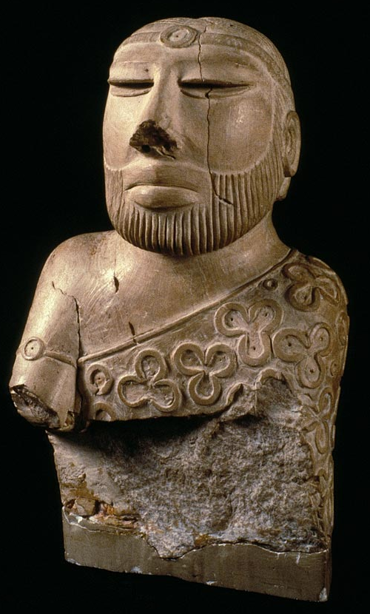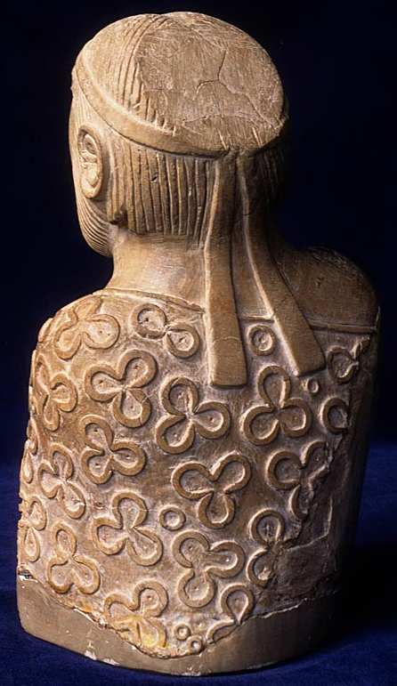

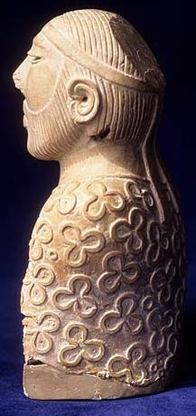

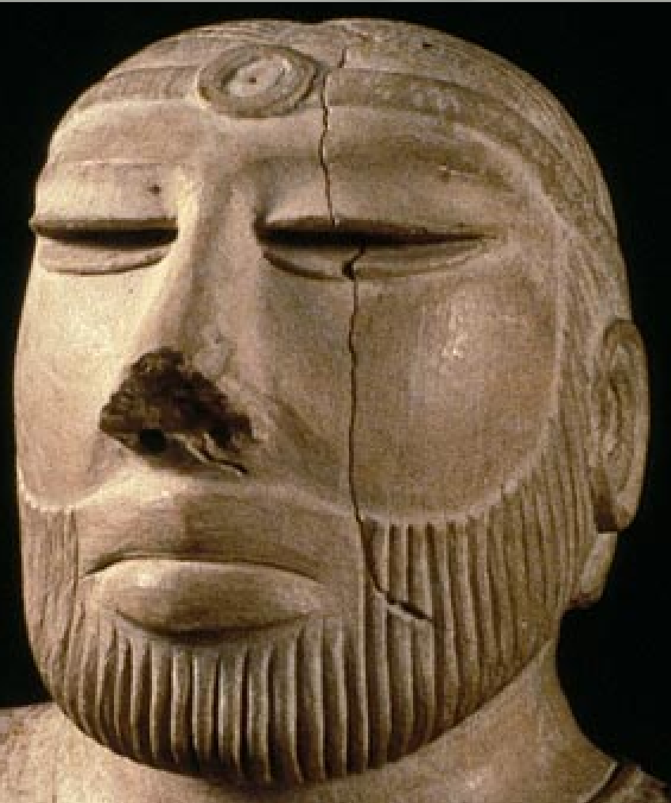 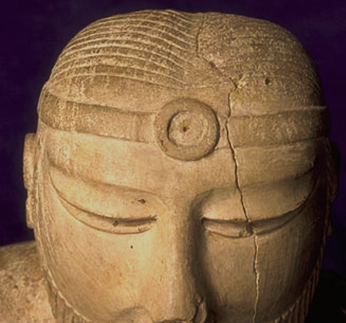

Figs. 1-5. Indus Valley-Mohenjo Daro-Metals Priest-Steatite-2000 BCE.

Replica of original male torso from Mohenjodaro. National Museum of Karachi. The lower chest and lower humerus have disintegrated and the parietal bone area is flattened. Images of original from <https://www.sindhidunya.com/wp-content/uploads/2015/04/4500-years-old-Statue-of-Parohat-Raja.png>

**Case no.: 3**

**Accession Number: A….**

**Formal Label:** Indus Valley-Mohenjo Daro-Metals Priest-Steatite-2000 BCE

**Display Description:**

**This figure is finally identified for the first time as a metals priest or a master metalsmith. His sarong has emblazoned (one, two and three) circles, धातु *dhātu*, an Indus Script hieroglyph that signifies *dhā̆vaḍ, dhamaga*, one who smelts metal ores, a blacksmith who works in combinations of one, two and three mineral ores, पोतृ, *pōtṟ*, a “metals priest.” These circles were originally painted with red ochre, a common iron ore. In order to further identify his metal smithing ability, his beard has been meticulously cut with a** ***metal*** **razor. In addition, he wears two circular ornaments on his forehead and on his arm band, and these would have been recognized as being valuable metal (i.e. gold) accessories.**

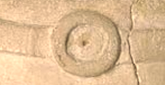 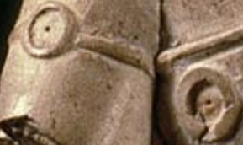 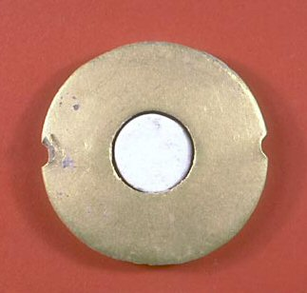

Fig. 6. Front, detail of head-band disc. Fig.. 7. Front, detail of arm band disc. Fig. 8. A small gold disc excavated at Mohenjo Daro that is suggestive of the Metals Priest’s disc accessories.

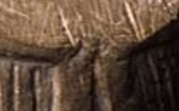

Fig. 9. Rear, detail of streamers from the head-band that may be tied with a square knot.

Physical traits of the individual include a steep angular frontal bone, a straight nose without a dip, a central depression along the metopic suture on top of his head that extends from the frontal bone to the parietal bone. Individual has thick lips.

Additional cultural traits of the individual include 1) hair that is carefully combed from the center laterally to the sides; 2) a parietal area at the back of the head that has been abraded into a flat surface suggesting that it may have held a separate hair-piece; 3) a square knot tying his head band in back with two streamers.

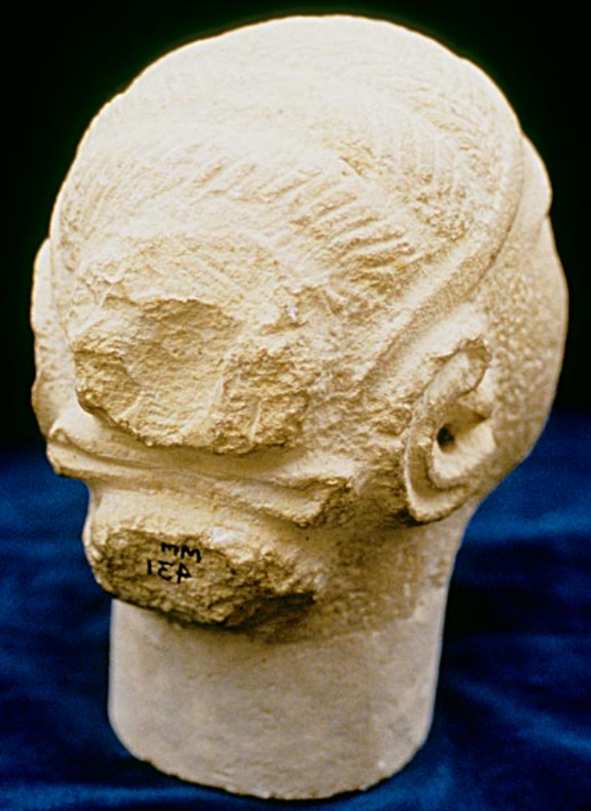

Fig. 10. A head from Mohenjo Daro (National Museum, Karachi, mm.IE) showing the position of a separate hair piece at the back of the head above a tied bow and head-band. From https://www.harappa.com/sites/default/files/424786_10150615875269846_290696826_n.jpg

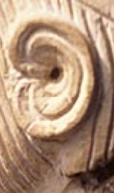 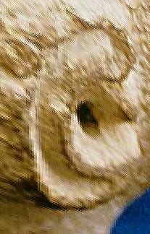

Figs. 11, 12. The double-band ears (of Figs. 2 and 10 above) appear to follow a Mohenjo Daro standard design pattern.

**LC Classification:** DS392.2.

**Date or Time Horizon:** 2600-1900 BCE

**Geographical Area:** Indus Valley, Mohenjo Daro site

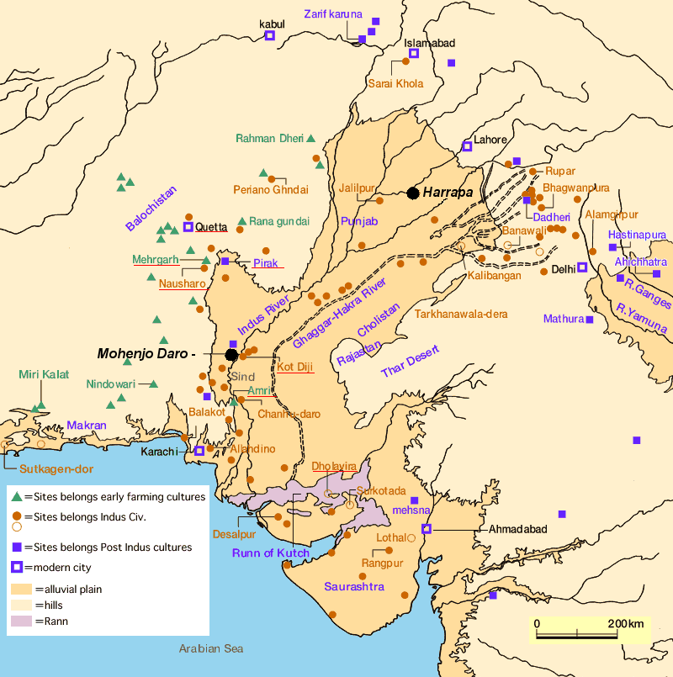

Fig. 13. Map of Indus civilization from https://encrypted-tbn0.gstatic.com/images?q=tbn:ANd9GcSnoolUCyM4saSet1fqKCqzYEWJhfDBzJsATILKpXYgG8P2maLY.

**Map, GPS coordinates:** [27°19′45″N 68°08′20″E](https://tools.wmflabs.org/geohack/geohack.php?pagename=Mohenjo-daro&params=27_19_45_N_68_08_20_E_type:landmark)

**Cultural Affiliation:** Mohenjo-Daro, DK 1909

**Media:** steatite, red pigment (cinnabar)

**Dimensions:** 17.5 cm height, 11 cm width  
**Weight: n/a**

**Condition: Original; and replica**.

**Provenance:** Original, National Museum, Karachi, 50.852

**Discussion:**

Smelting of metals in India dates to the Indus Script hieroglyphs of trefoil *tri-dhātu*signifiers of metalwork, ca. 3200 BCE. Metalwork in a *kole.l* 'smithy' evolved into *kole.l* 'temple' where Nataraja நடராஜர் नटराज, "the lord of dance", (the Hindu god Shiva) is the ecstatic cosmic dancer of Ananda Tandavam or Rudra Tandavam, the first devoted to creation, the second committed to destruction. As a creator, the **पोतृ, *pōtṟ*, “**metals priest**,”** is adorned with the hieroglyphs of one, two and three dotted circles of the revered *dhā̆vaḍ*, the “iron-smelter” and *dhamaga,* the “blacksmith,”  who parallels the creative ability of Nataraja.

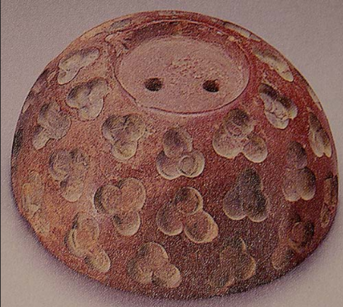

Fig. 14. Ritual bowl, ca 2000 BCE, showing the trefoil or three-circles design, *tri-dhātu*, an Indus Script hieroglyph used to signify *dhā̆vaḍ, dhamaga*'a metals smelter, a blacksmith' working with three mineral ores. National Museum, Karachi, Pakistan. From <http://www.exoticindiaart.com/artimages/bowl.jpg>.

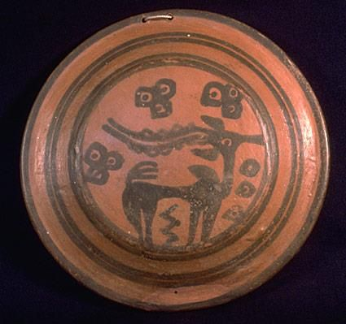

Fig. 14. Ritual bowl, ca 2000 BCE, showing the trefoil or three-circles design, *tri-dhātu*, an Indus Script hieroglyph used to signify *dhā̆vaḍ, dhamaga*'a metals smelter, a blacksmith' working with three mineral ores. National Museum, Karachi, Pakistan. From

<https://i.pinimg.com/736x/82/92/2e/82922edda84039fdf078b809ea69b837--harappan-indus-valley-civilization.jpg>

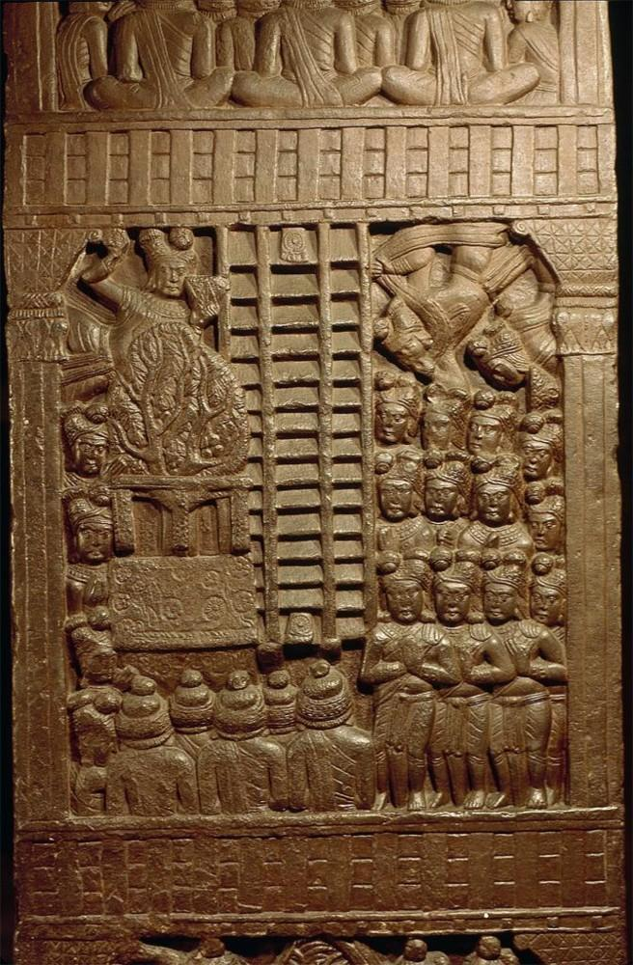

The Bharhut sculptural frieze.

The gathered men signify a *dāvaṇi “*assemblage' aguild of *dhā̆vaḍ* or *“*smelter-workers.”

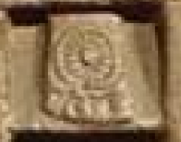

The two feet on the rungs of the ladder bound to a spoked wheel signify *kunda*, an opening in the hub of a wheel (nave) to connect with the axle (Santali) Rebus: *kundam, kund*,a sacrificial fire-pit (Skt.), *kunda, kundār*‘metal turner’.

*eraka* 'hub (nave) of a wheel' rebus *erako* “molten cast” *eraka, arka* 'copper, gold'

*arA* अर 'spoke of a wheel' rebus: *Ara* 'brass'.

*śrēṣṭrī*'ladder' Rebus: *seṭh* ʻ head of a guild, Members of the guild (working with a metal smelter) are: blacksmith, turner, smelter, coppersmith, ironsmith (magnetite ore). The ladder signifies *seṭh* 'head of an artisan guild'.

Hieroglyph:  *dāvaṇi* 'an assemblage' signified by the group of worshippers on the sculptural frieze; *dāvaṇi* 'upper garment worn by worshippers'

In Bauddham tradition, this is dhamma cakka. A pun on the word 'dhamma' is dhmA 'smelter-blower', dhmAtr 'blower of a smelter furnace'.

Tree-in-railing (as a venerated object): kuThi 'tree' rebus: kuThi 'smelter'. vedika (railing)

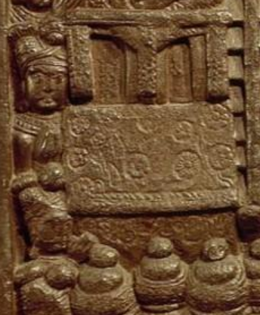

Below the vedika 'platform' of the tree a panel signifies writing with hieroglyphs: *daLa* 'petals' rebus: *dhALako*'ingots'.

The flowers on the slab signified as hieroglyphs are: *karadI* 'safflowers' rebus: *karaDi* 'hard alloys'

**References:**

Chatterjee, T. 2002. *Knowledge and Freedom in Indian Philosophy*. Lanham, MD: Lexington Books.

Marshall, John. 1931. *Mohenjo-daro and the Indus civilization: being an official account of archæological excavations at Mohenjo-daro carried out by the government of India between the years 1922 and 1927.* London: A. Probsthain.

|  |  |
| --- | --- |
|  |  |

Sharma. A. 1982. *The Puruṣārthas: a study in Hindu axiology*. East Lansing: Asian Studies Center, Michigan State University.

Sharma. A. 1999. “The Puruṣārthas: An Axiological Exploration of Hinduism,” *The Journal of Religious Ethics*, 27(2): 223-256.